10 How to Change Clip Speed and Duration in DaVinci Resolve

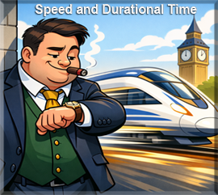
Duration changes how long the clip stays on screen. Speed changes how fast the clip plays.

Changing Duration

Changing the time that a clip runs, is called duration. Now this is very easy to do in the Edit Panel, just put your clip on the timeline.

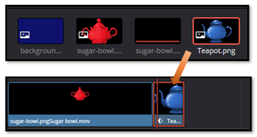

Right click and select, either change speed, or duration

Right click on the clip you want to change, to bring up the context menu. Then just choose, Change Clip Duration.
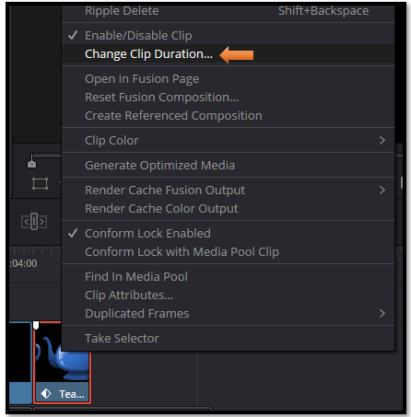

You can either change the duration to a very specific time, or choose a preset setting.
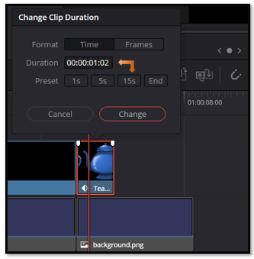

Adding Duration time, can also be done by just stretching out the clip on the timeline and this will also slow down the speed of a clip
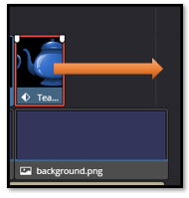

Changing Time
Changing time is not given to us in the right click menu, until you have an actual movie clip. This means it needs to be rendered. We can take a clip and actually render an animated clip right on the time line. My sugar bowl has been animated by placing movement and marking those movements with key frames in the Inspector.
“Speed controls only appear on clips that contain real video frames.”
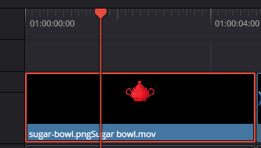

Render a Clip in Place
Right click on the clip of the sugar bowl on the timeline. Choose to Render in Place.

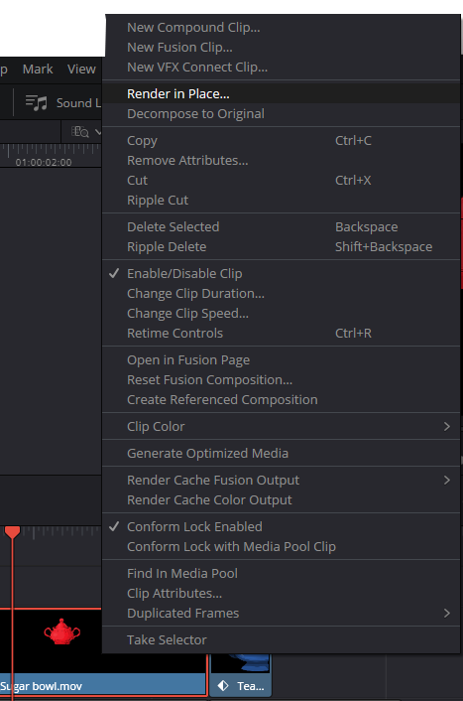
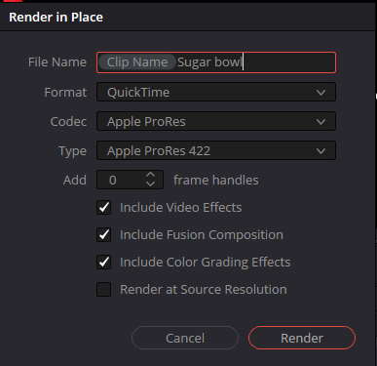
Then you can choose to change the speed
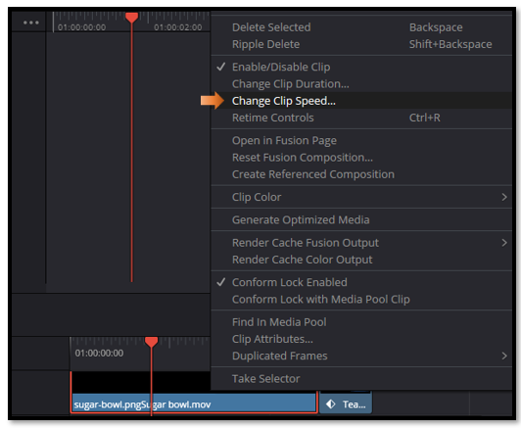
Understanding the difference between duration and speed gives you a lot more control over how your clips behave on the timeline. Duration can be changed on anything, but speed changes only appear once a clip contains real video frames. So, if you’ve animated something like a Text+ or a PNG, just render it in place first, and Resolve will treat it like any other video clip. Once you know this little workflow trick, adjusting timing becomes simple and predictable, and you can shape your edits exactly the way you want.

